Navigating the Financial Aid Process: Insights from California’s High School Class of 2023
Elizabeth Friedmann, Jaime Ramirez-Mendoza, Michal Kurlaender, Paco Martorell, Stefano Cantos, Jessica Moldoff and Ryan Fuller
April 2024

Many low-income students face financial barriers when making decisions about enrolling in college. Receipt of financial aid has been linked to increased college enrollment, persistence, and graduation (Bettinger et al, 2012; Dynarski et al, 2022); yet, the complexities of the financial aid process—particularly the Free Application for Federal Student Aid (FAFSA)—continue to pose a persistent hurdle for students (Bahr et al, 2018). Students must complete this crucial first step in order to begin the process of receiving any federal financial aid (including the Pell Grant and Direct Loans), but many fail to successfully apply. In 2023-24, the federal government implemented a new FAFSA with the goal of easing the required information for students to complete. Alas, its ongoing internal errors and resulting late rollout have caused significant delays and complications for students and institutions (Knox, 2024). The impact of this failed new FAFSA rollout remains to be seen, but as we detail below, it follows high school students’ clear concerns about college affordability and the process for financial aid receipt.
In the 2020-21 school year, only 53% of California high school seniors completed the FAFSA, leaving them unable to collect millions of dollars in financial aid (National College Attainment Network, n.d.). To address this critical component of the college enrollment process, the California State Legislature passed Assembly Bill 469, which required California high schools and districts to confirm that high school seniors submitted the FAFSA or California Dream Act Application (CADAA), beginning with the 2022-23 graduating class. The goal of this policy is to expand financial aid access to students who may otherwise be unaware of their aid eligibility. California is now among several states that require high school seniors to submit a FAFSA - including Louisiana, Texas, Alabama, Illinois, New Hampshire, and Connecticut.
In light of this new requirement and ongoing complexities of financial aid processes, the California Education Lab at UC Davis and the California Student Aid Commission (CSAC) sought to understand student experiences with the financial aid process through a survey of high school seniors from the Class of 2023. In this report, we summarize the survey results, describing how students experienced the new FAFSA/CADAA requirement, their sources of information and support when submitting the application, and their plans to pay for college. We investigate differences across student income, race, and intended type of college enrollment. We also explore how students described—in their own words—the barriers and concerns related to financial aid and how that could impact their transition to college.

About the Survey [TEXT BOX]
In partnership with the California Student Aid Commission (CSAC), the California Education Lab at UC Davis designed and administered a survey to the full population of California high school seniors who submitted a FAFSA/CADAA for the 2023-24 academic year. Using a mix of Likert-scale, selected response, and open-ended questions, the survey asked about students’ experiences with the financial aid process, what support and information students received about financial aid, and their worries about affording college. The survey was sent via email and was open from mid-May to mid-June 2023. The sample of survey respondents includes more than 10,000 students, resulting in a 4% response rate. Despite this low response rate, respondents represent a broad swath of the first graduating class subject to the mandate to submit the FAFSA/CADAA and is a large sample size. Drawing on an existing data-sharing agreement between the California Education Lab at UC Davis and CSAC, individual survey responses were linked to administrative and financial aid records held by CSAC, allowing analysis of differences by Expected Family Contribution (EFC), race, and where students planned to attend college (California Community College, California State University, University of California).

Completing the FAFSA/CADAA

Expectations of Students for the FAFSA/CADAA Submission Requirement
The Class of 2023 was the first cohort to be required to complete the FAFSA/CADAA. Figure 1 shows that overall, 81% of survey respondents reported being required by their high school to submit the FAFSA/CADAA, but this varied by subgroup. Almost 90% of students with a zero Expected Family Contribution (EFC)—the lowest income group—reported that their high school required them to complete the FAFSA/CADAA. Generally, the higher the EFC, the less likely students were to report attending a high school that required the completion of the FAFSA/CADAA. Specifically, 84% of students with an EFC above zero, but still eligible for the federal Pell Grant, reported being required to submit the FAFSA/CADAA, compared to only 71% of students with an EFC that was not at the eligibility level for a Pell Grant.

WHAT IS EFC? [TEXT BOX]
To determine a student’s financial need for college, a number known as the Expected Family Contribution (EFC) is calculated from information reported on a student’s FAFSA or CADAA, including income, assets, household size, and dependency status. A lower EFC is associated with lower income/assets and greater financial need, whereas a higher EFC is indicative of higher family income/assets and less financial need. Beginning in the 2024-25 academic year, EFC will be replaced with the new Student Aid Indicator (SAI), which is based on the newly streamlined FAFSA form.

Figure 1. High School Requirement by Financial Need
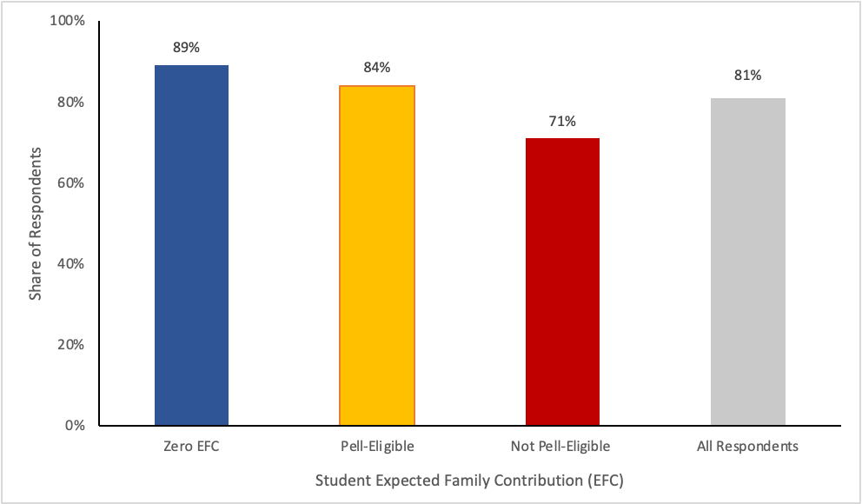
Note: Pell-eligible is defined as students with an EFC above zero but equal to or below the maximum Pell Grant eligibility EFC of $6,656. The Not Pell-eligible column is students with an EFC above $6,656. The sample includes all students who answered the question “Were you required by your high school to fill out the FAFSA/CADAA?” (N=9,863).

QUOTES
“My biggest challenge I think is being the first member of my family to attend college and worrying about the financial needs to pay for my education.”

“My parents can’t afford to pay for any of college at all, and so I’ll have to figure out loans and everything else, and especially since I don’t have a job yet, I’m getting really stressed out about how I’m going to deal with cost, even though I’m going to one of the cheapest schools I could have gone to.”

How Students Learned About FAFSA/CADAA
The majority of survey respondents identified high school staff (83%) as their primary source for learning about the importance of completing a financial aid application. Other common sources of information were word of mouth (28%), print media (20%), and financial aid workshops (11%). Few students reported learning from other sources, including online websites and public service announcements.

Figure 2. Sources of Information about Financial Aid

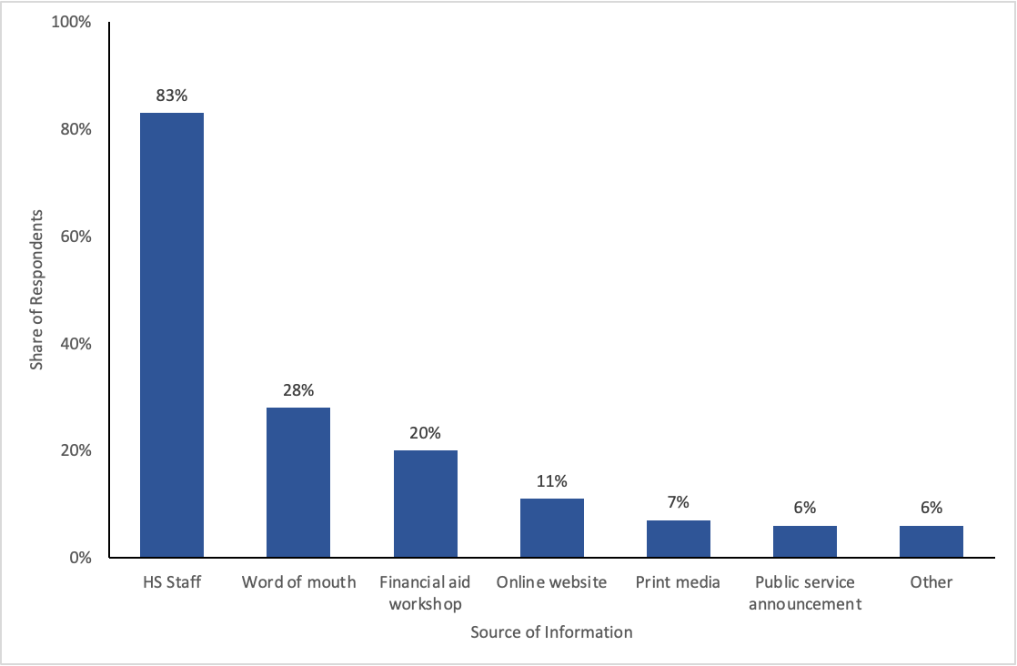
Note: Sample for this figure includes all students who answered the question “How did you hear about the importance of submitting a financial aid application?” (N=9,891)

Supports for Completing the FAFSA/CADAA
When asked about support in submitting the FAFSA/CADAA, approximately half of students indicated receiving parental help (Figure 3a). Other common sources of support were high school counselors (45%), financial aid workshops at high schools (30%), and teachers (22%).

There were some differences in FAFSA/CADAA support by income (Figure 3b). Only 29% of respondents with a Zero EFC reported that their parents helped them with the FAFSA/CADAA, compared to 71% who were not Pell-eligible. Student respondents with the lowest EFC were more likely to have assistance from high school counselors (54%) compared to their higher-income peers (34%). Respondents with a lower EFC were also more likely to report receiving support at financial aid workshops hosted at their high school.

Figure 3a. Sources of Support in Submitting FAFSA/CADAA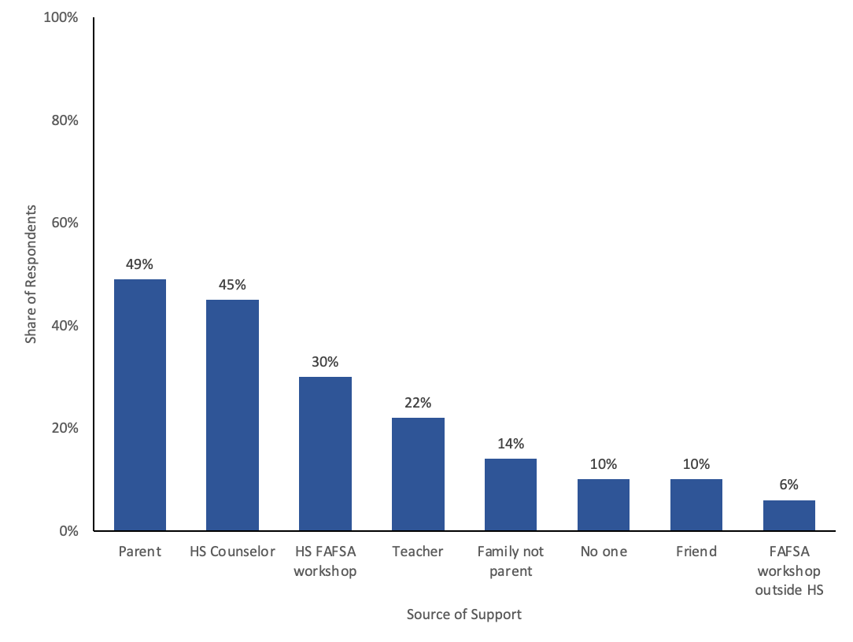

Note: Sample for this figure includes all students who answered the question “Please tell us which of the following helped you complete the FAFSA/CADAA (Check all that apply)” (N=9,704)

Figure 3b. FAFSA/CADAA Support by EFC

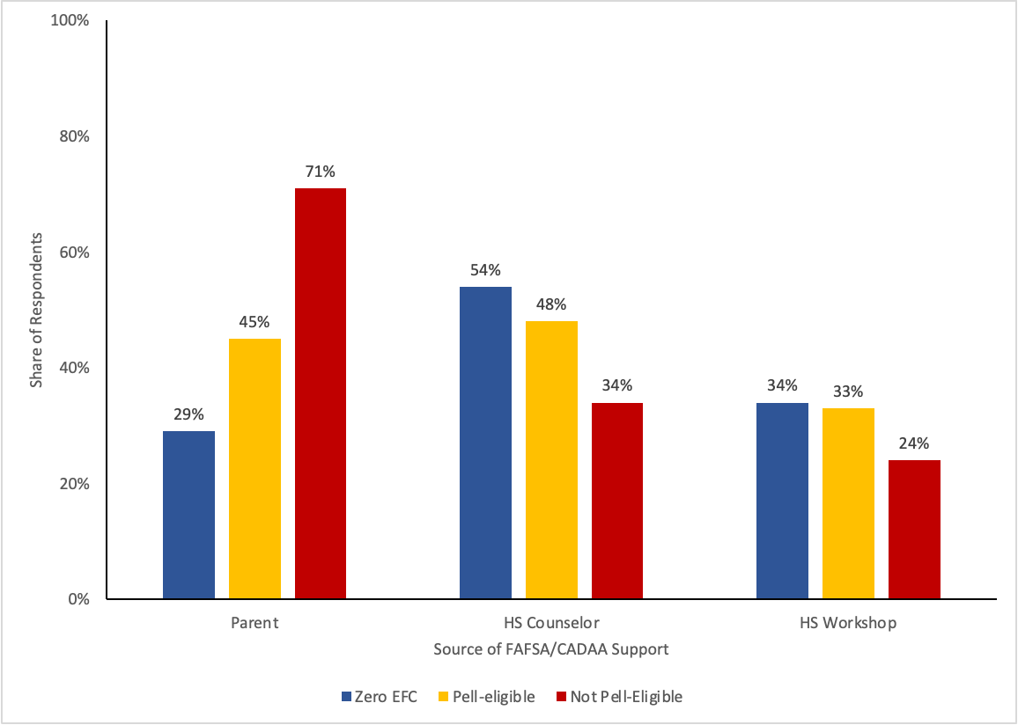
Note: Sample for this figure includes all students who answered the question “Please tell us which of the following helped you complete the FAFSA/CADAA” (N=9,704)

QUOTE
“I’m scared about payments I’ll have to make because my college’s living expenses are very high. I’m also the first to go to college in my family, so I’ve had to do a lot by myself but the counselors were helpful. I’m scared that the level of help won’t be there at my college since there are so many more students they’ll focus on.”

We also explore differences by student race/ethnicity and income because income is not evenly distributed across subgroups. For instance, more Latinx and Black students are lower-income compared to White and Asian students, as 73% of Black and 81% of Latinx students are eligible for Pell Grants compared to 42% of Asian and 31% of White students. Therefore, we present results that show racial/ethnic differences within each EFC category. While we report differences for Asian students, it is important to note that “Asian” is a broad category that includes many ethnic groups—each with their own distinct history and educational experiences (Zhou, 2021). This broad categorization may mask educational inequities for racial/ethnic subgroups when analyzed collectively.

Even when comparing students within the same EFC bin, there are striking differences in sources of FAFSA/CADAA support by race/ethnicity (Appendix Figure A1). Specifically, just 22% of the lowest-income Latinx respondents reported their parents helping them submit the application, compared to 38% of Asian and almost half of White students. A higher share of Latinx (58%) and Black (51%) respondents reported receiving help from a high school counselor compared to their Asian and White peers, and these trends hold true across income categories.

Figure 3c. FAFSA/CADAA supports by Race and EFC

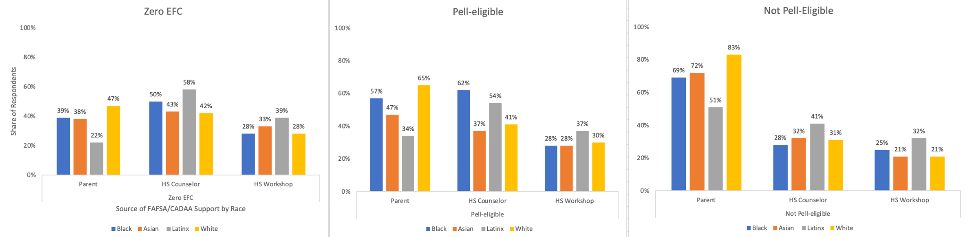
Note: Sample for this figure includes all students who answered the question “Please tell us which of the following helped you complete the FAFSA/CADAA” (N=9,704)

College Plans
Of the nearly 10,000 survey respondents, 95% indicated that they planned to enroll in college in Fall 2023. The type of college in which respondents planned to enroll varied significantly by financial need (Figure 4a). Zero EFC students were much more likely to have plans for attending a California Community College (CCC) and higher-income (not Pell-eligible) students were much more likely to indicate plans to enroll at a University of California (UC) campus (29%). Rates of California State University (CSU) attendance were fairly stable across income groups.

Figure 4a. Planned College Segment by EFC

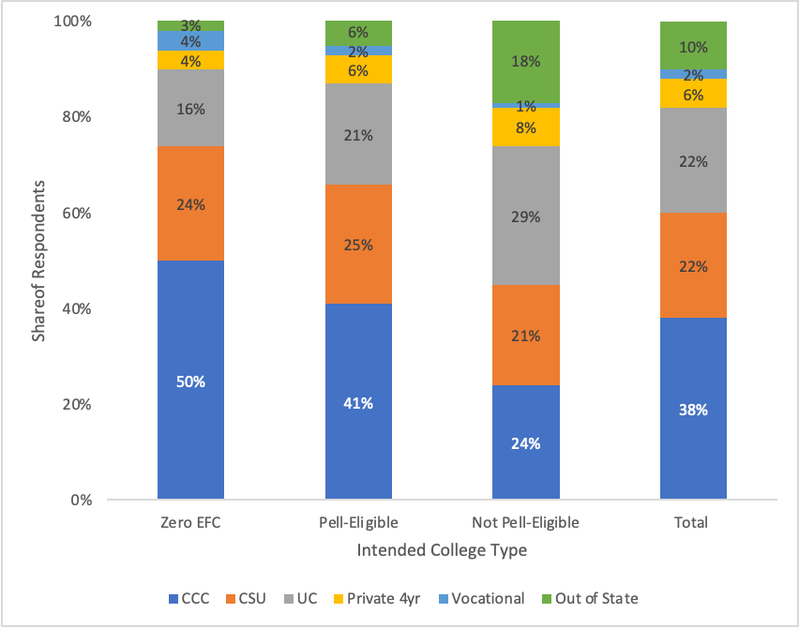
Note: Sample for this figure is limited to respondents who indicated plans to attend college in Fall 2023 and answered the question “Where do you plan to attend college this fall?” (N=9,172).

There are also notable differences in where students planned to enroll by race/ethnicity within income categories (Figure 4b). Across all income categories, a higher share of Latinx respondents planned to enroll at a CCC than a four-year institution. Even among the highest-income respondents (not Pell-eligible), over 40% of Latinx students planned to enroll at a CCC compared to 20% of White students and only 12% of Asian students. Higher-income Latinx respondents were also much less likely to plan to attend a UC (16%) compared to their White (24%), Black (37%), and Asian (50%) peers.

Figure 4b. Planned College Segment by Race and EFC
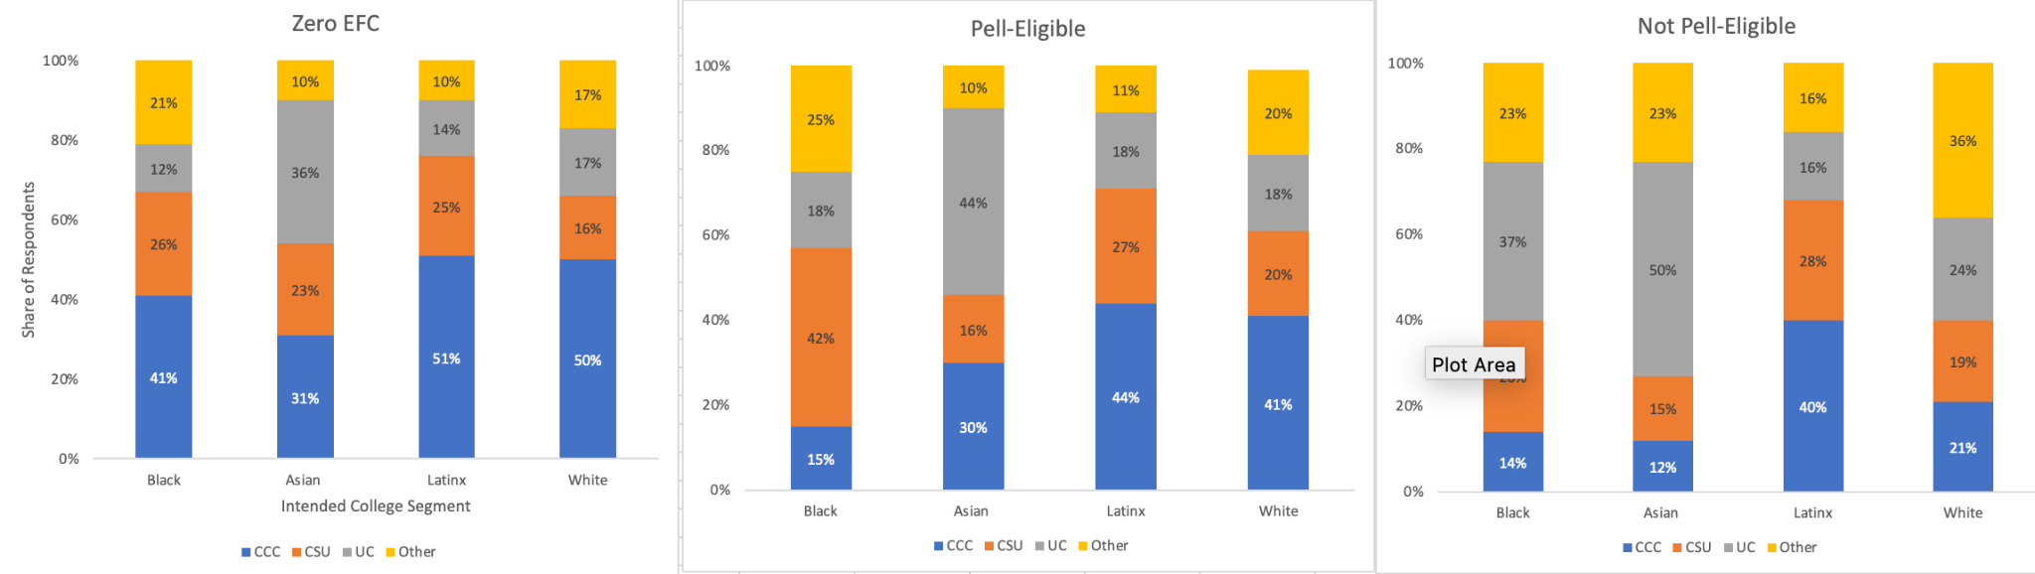
Note: Sample for this figure is limited to respondents who indicated plans to attend college in Fall 2023 and answered the question “Where do you plan to attend college this fall?” (N=9,172). “Other” combines private four-year institutions, vocational programs, and out-of-state institutions because of cell size restrictions.

Communication About Financial Aid
The survey also asked students about communication they had received from colleges regarding financial aid. Nearly three-quarters of respondents said their college contacted them about their financial aid. The most common communication was a financial aid award offer letter (67%), and just over half of students reported notification of the verification process and the need to provide additional documentation before receiving aid. Other reasons for contact were information about loans (43%) and work study (29%).

College communication about financial aid varied substantially by the type of college students planned to enroll in. Figure 5 shows that almost 90% of survey respondents planning to attend UC and 81% of those planning to attend CSU reported that their college had contacted them about financial aid. In contrast, only 56% of respondents planning to attend a CCC had been contacted about their financial aid.

QUOTE:
“I don’t know how much financial aid I will get, and I am not sure if I will be able to attend college for that reason.”

“I believe that I will struggle financially in college because being a DREAMer limits me from so many opportunities and I am not quite sure if I will be receiving financial aid for college.”

Figure 5. College Contact for Financial Aid by Segment

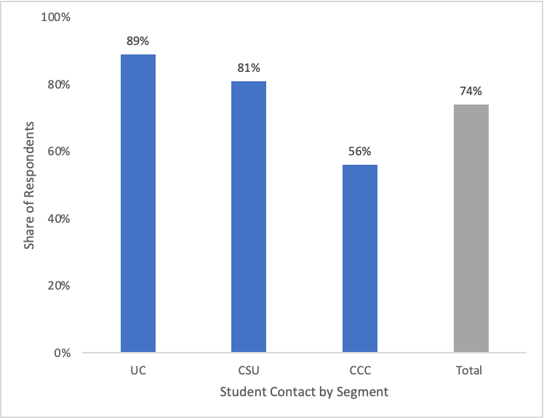
Note: Sample for this figure is limited to respondents who indicated plans to attend college in Fall 2023 and answered the question “Has your college contacted you (e.g. email, letter, phone call) about your financial aid?” (N=9,172).

Financing College
Survey respondents intending to enroll in college in Fall 2023 planned to pay for college in a variety of ways (Figure 6), including scholarships (51%), need-based grants (50%) such as the Pell Grant and Cal Grant, money from other people (44%), their own savings (35%), and loans (33%). Over half of respondents also planned to work while enrolled in college to finance their education.

Figure 6. Methods for Paying for College
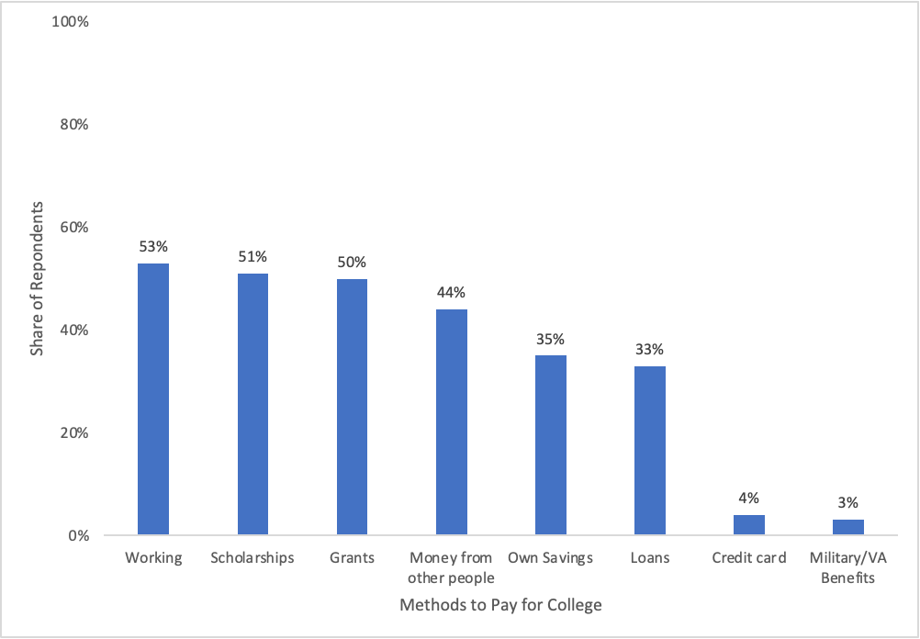
Note: Sample for this figure is limited to respondents who indicated plans to attend college in Fall 2023 and answered the question “How do you plan to pay college tuition and fees? (Check all that apply)” (N=8,174).

There were similar rates of working, credit cards, and military/VA benefits across all subgroups (see Appendix Figures A2-A4), but there are some substantial differences in how students plan to pay for college by family income and intended college of enrollment (Figure 7a). While respondents across the income distribution showed similar rates of planning for grants, scholarships, and working while enrolled, higher-income students (not Pell-eligible) were more likely to report relying on money from other people (68%) and loans (41%) compared to their lower-income peers. Moreover, there are sizable differences in how respondents intend to pay for college across the higher education segments. Respondents planning to attend a UC were much more likely to rely on scholarships (62%) and loans (39%) compared to students planning to enroll at a CCC or CSU. Notably, only 47% of students planning to attend a CCC were planning to receive need-based grants to finance their education.

Figure 7a. Methods of Paying for College by Subgroup
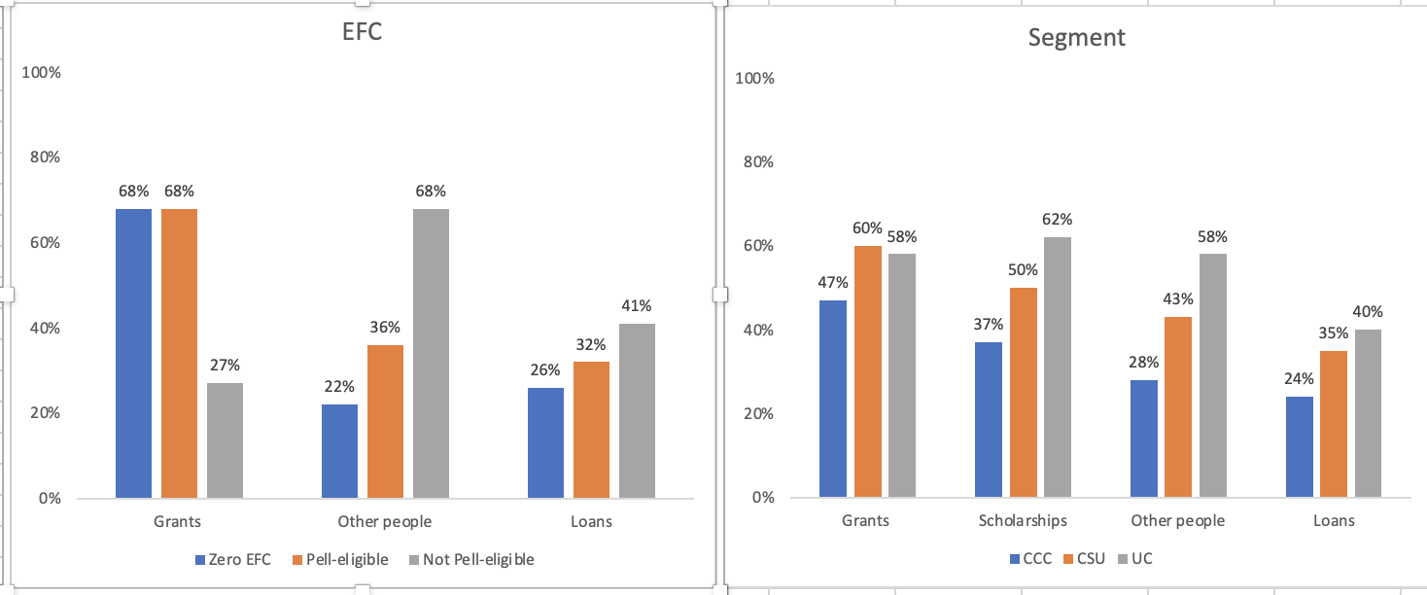
Note: Sample for this figure is limited to respondents who indicated plans to attend college in Fall 2023 and answered the question “How do you plan to pay college tuition and fees? (Check all that apply)” (N=8,174).

There are also some notable differences by race and income (Figure 7b). Among the lowest-income students (Zero EFC), Asian students were much more likely (38%) to report relying on money from other people compared to 26% of Black students, 25% of White students, and 19% of Latinx students. Across all income groups, Latinx students were less likely to take out loans, and Asian students were the most likely to receive money from other people.

Figure 7b. Methods of Paying for College by Race and EFC

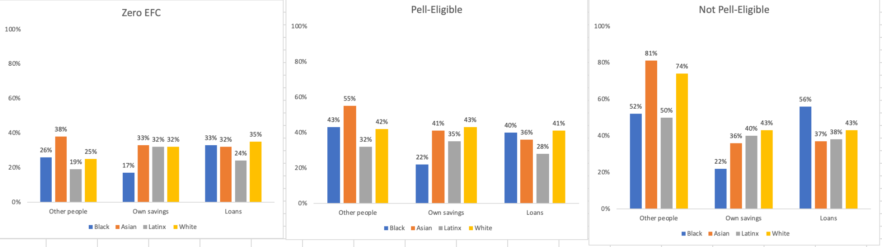
Note: Sample for this figure is limited to respondents who indicated plans to attend college in Fall 2023 and answered the question “How do you plan to pay college tuition and fees? (Check all that apply)” (N=8,174).

Student Concerns

“I’ll miss my high school life, but more importantly than that is money. We are receiving zero financial aid even though I have a single mother supporting two kids at home and it’s going to be really hard for her to afford my education. I’ll feel really guilty about that. I’m working a minimum wage job trying to save up money to help pay but I’ll barely make a dent in all the payments even with my entire life’s savings.”

Survey results showed that students are concerned about the transition from high school to college (Hurtt et al., 2024). Chief among those concerns were the financial demands of pursuing higher education (Figure 8a). The majority of survey respondents expressed that they were somewhat or very worried about being able to cover tuition/fees (63%), pay for living expenses (58%), and balance work and school obligations (51%).

Figure 8a. Financial Concerns
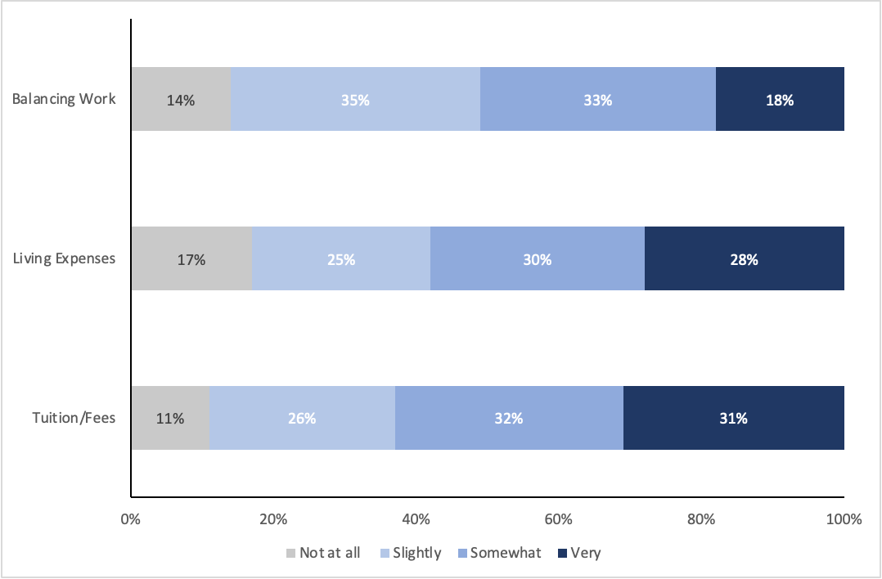
Note: Sample for this figure is limited to respondents who indicated plans to attend college in Fall 2023 and answered the question “When you think about college, how worried are you about the following?” (N=7,957).

Concerns about the financial aspects of going to college were particularly pronounced among lower-income students. Figure 8b shows that over two-thirds of all Zero EFC and Pell-eligible students were somewhat or very worried about paying tuition and fees, but even 55% of higher-income students (not Pell-eligible) still expressed substantial concern. There were similar patterns for paying for living expenses, with a higher share of low-income students worried and over half of higher-income students showing similar concern. Finally, approximately 55% of all Pell-eligible students (including Zero EFC) were somewhat or very worried about balancing work obligations with school.

Figure 8b. Student Financial Concerns by EFC
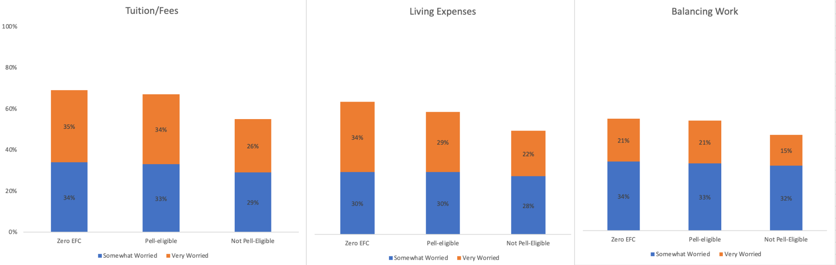
Note: Sample for this figure is limited to respondents who indicated plans to attend college in Fall 2023 and answered the question “When you think about college, how worried are you about the following?” (N=7,957).

Financing College: High School Seniors Voice Their Concerns

Concerns about the financial stress of paying for college were echoed in students’ responses to open-ended questions. When asked, “What do you think is the biggest challenge you’ll face in college?”, one-quarter of the approximately 6,100 students responding to the question mentioned some aspect of affordability or concerns about the costs of college. Work obligations and cost of attendance were frequently cited concerns. Other themes included student debt, transportation, familial obligations, and general financial uncertainty. Many students reported compounding concerns regarding affordability and how that impacts their transition to college, as exemplified by one student’s reflection:

“I’m worried about the financial challenges I’ll face. I’ll need to think about food, working, and managing my time and money. It’s a lot. I’ll be overwhelmed at first and won’t be sure about anything. I’ll need to worry about multiple things, not just my education or grades.”

Respondents also described concerns for finding, maintaining, and balancing a job while being a student, with responses such as: “balancing my job with school”, “I need to find work to pay off my bills while in school”, and “establishing personal finance security.” The general trepidation of keeping up with the cost of attendance was conveyed with responses about concerns about paying for housing and tuition and buying books and supplies (e.g., “not being able to afford it” or “paying rent and tuition”). Other students described their worries about not qualifying for or receiving aid to finance their college attendance; for example, “I received no FAFSA, so I don’t know how my family and I will pay for college” or “I receive nothing in aid, and my parents can’t afford to send me to college.”

Respondents further reported concerns about affording basic necessities, such as food and transportation, while in college. Some noted concerns about paying for food with comments such as: “I worry about paying for meals” or “paying for food.” Others described concerns about transportation costs such as gas, car maintenance, public transit, or “being able to afford airfare tickets to go back home.” For some students, financial concerns extended to familial obligations, including the need to send money home. “The biggest challenge I’ll face in college will have to be financial more than anything because both my parents are unemployed.”

“My biggest challenge I think I would face is financially at home and school. As well trying to balance my work life, social life and home life. But the most challenging is the financial responsibility for my family.”

Finally, many respondents conveyed concerns about accumulating debt and paying back loans after graduation with responses such as: “My biggest concern is debt”, or “I’m worried about paying off what I owe after I’m done.” Another student expressed,

“Considering I am a first-generation immigrant with parents that make an income that is considered below average, paying for tuition, books, and other of my college endeavors would be a struggle to pay for. Though I am well qualified for financial aid (FAFSA and Cal Grants), paying for the subsidized loans is quite worrisome and what I consider is the biggest challenge.”

Conclusion
Results from this survey of California high school seniors from the Class of 2023 provide important insights into how high school seniors plan to pay for college and how they experience the financial aid process. In light of the new FAFSA/CADAA requirement, it is reassuring that over 80% of survey respondents were aware that they were required to submit the application. While this does not indicate universal awareness, this self-reported measure is likely an underestimate. It is likely additional students were instructed to submit the application in a different way (e.g., through an AVID or other college preparatory course or program) without realizing high schools need to ensure students complete the application.

The sources of support students received in completing the FAFSA/CADAA varied by both family income and race/ethnicity. Lower-income students relied more on high school counselors and FAFSA workshops for help in completing their applications, while their higher-income peers were more likely to rely on parental support. Notably, Latinx students were least likely to report parental support in completing their aid application, regardless of financial need. Even within the same income range, Latinx students were more likely to rely on high school counselors and workshops, while White and Asian students reported more parental support. These differences should not be interpreted as a lack of interest from Latinx parents, but rather an indication of continued information barriers that many Latinx families experience in supporting their children’s schooling despite the similarly high value placed on their children’s college education (Stepler, 2016). An additional hurdle might result from mixed-status families, in which the students are U.S. citizens but the parents may not be. These differences highlight the critical role high schools play in helping students— especially minoritized populations—with the FAFSA/CADAA (and other college application processes) in order to address the persistent equity gaps in college access and completion.

Survey results also show a significant gap in communication from financial aid offices by college segment. While the majority of respondents planning to enroll at a UC or CSU had some contact from the financial aid office of their intended college, only half of students who planned to attend a CCC had received any communication. By May of their senior year, many high school students were making decisions about if and where to enroll in college, and an important part of this decision-making is information from colleges about financial aid. Part of this difference, however, may be explained by the differing timelines for application and enrollment decisions at CCC and four-year institutions. Students planning to attend a four-year institution must formally apply in the fall of their senior year and make enrollment commitments in May. In contrast, the CCC has a rolling application process, so it is possible that some of the students intending to enroll at a CCC had not yet completed the application, or even listed their intended community college campus on the FAFSA/CADAA. Nevertheless, even with the CCC’s rolling admissions, this late spring period is a crucial time for students to be making college decisions. If students do not have a full and accurate picture of how they can pay for college, it may dampen the likelihood of their enrollment. This is especially concerning given that the CCC disproportionately enrolls more first-generation, lower-income, and students of color than the public four-year systems (CCC Chancellor’s Office, 2023).

Equally concerning is that over half of students reported being flagged for verification as students may not receive their aid if they do not have the knowledge or resources to navigate the process. Once flagged, verification must be completed before a student can receive their financial aid award funds, but the verification process can be complex and lengthy, creating a substantial barrier—even for students who have already successfully submitted a FAFSA (Evans et al, 2019).

Results also indicate a wide range of how students planned to pay for college upon enrollment. Notably, less than half of respondents planning to attend a CCC expected to receive need-based grants to finance their education, despite the CCC enrolling a higher share of low-income students compared to the CSU and UC. This may be due in part to a lack of knowledge about aid among CCC students, as evidenced by their lower reported rates of communication about financial aid. It is possible that some respondents would be receiving notification of Pell Grant eligibility or other state aid closer to the beginning of the fall term.

Over half of respondents in our sample expressed concerns about affording tuition, living expenses, and balancing work while in college. This was especially pronounced among the lowest-income students with a Zero EFC. Further exploration through open-ended responses unveiled an expansive set of concerns regarding college affordability that students grapple with, including balancing work and school, covering basic needs and familial obligations, and fear of accruing debt.

Statewide financial aid submission requirements can increase application completions and college enrollment without negatively impacting high school graduation rates. Yet challenges remain to ensure that the requirement is implemented equitably in order to achieve the policy’s goal to increase financial aid receipt. Our results are important for policymakers and practitioners to consider, as the new FAFSA/CADAA requirement needs to be coupled with equitable support systems to alleviate information barriers for students and strengthen policy pathways to greater college affordability. This is especially pressing given the complications of the rollout of the new FAFSA forms, as delays and errors have pushed back deadlines for financial aid processing and students receipt of offer letters. The long-term effects of these delays on college enrollment remain to be seen.

References
Bahr, S., Sparks, D. & Hoyer, K. M. (2018). Stats in brief: Why didn’t students complete a Free Application for Federal Student Aid (FAFSA)? A Detailed Look (pp. 1–22). U.S. Department of Education. Institute of Education Sciences, National Center for Education Statistics. https://nces.ed.gov/pubs2018/2018061.pdf

Bettinger, E. P., Long, B. T., Oreopoulos, P. & Sanbonmatsu, L. (2012). The role of application assistance and information in college decisions: Results from the H&R Block FAFSA experiment. The Quarterly Journal of Economics, 127(3), 1205–1242. https://doi.org/10.1093/qje/qjs017

CCC Chancellor’s Office (2023). Vision 2030: A roadmap for California Community Colleges https://www.cccco.edu/-/media/CCCCO-Website/docs/report/Vision-2030-A-Roadmap-for-California-Community-Colleges.pdf?la=en&hash=3B83F5221C4A7A8BEFA7E94D5BCBF540D2718013

Dynarski, S., Page, L. & Scott-Clayton, J. (2022). College costs, financial aid, and student decisions (NBER Working Paper No. 30275). National Bureau of Economic Research.
https://www.nber.org/papers/w30275

Evans, B., Nguyen, T., Tener, B., and Thomas, C. (2017). Federal Pell Grant eligibility and receipt: Explaining nonreceipt and changes to EFC using national and institutional data. Journal of Student Financial Aid, 47(3), 45-69. https://files.eric.ed.gov/fulltext/EJ1160078.pdf

Hurtt, A., Kurlaender, M., Sun, C., & Zhou, B. (2024, March). The transition to college: Voices from the Class of 2023. Sacramento, CA: Policy Analysis for California Education. https://edpolicyinca.org/publications/transition-college

Knox, L. (2024, April 15). FAFSA errors, corrections pile up as deadlines near. Inside Higher Ed. https://www.insidehighered.com/news/admissions/traditional-age/2024/04/15/fafsa-errors-corrections-pile-deadlines-near

National College Attainment Network (nd). Pell Grant dollars left on the table. https://public.tableau.com/app/profile/bill.debaun.national.college.access.network/viz/PellDollarsLeftontheTable/VisualDashboard

Stepler, R. (2016). Hispanic, Black parents see college degree as key for children’s success. Washington, D.C.: Pew Research Center. https://www.pewresearch.org/short-reads/2016/02/24/hispanic-black-parents-see-college-degree-as-key-for-childrens-success/#:~:text=Today%2C%2086%25%20of%20Hispanic%20parents,white%20parents%20say%20the%20same.

Zhou, L. (2021, May 5). The term “Asian American” doesn’t serve everyone it covers. Vox. https://www.vox.com/identities/22380197/asian-american-pacific-islander-aapi-heritage-anti-asian-hate-attacks
Appendix
Figure A1. EFC by Race
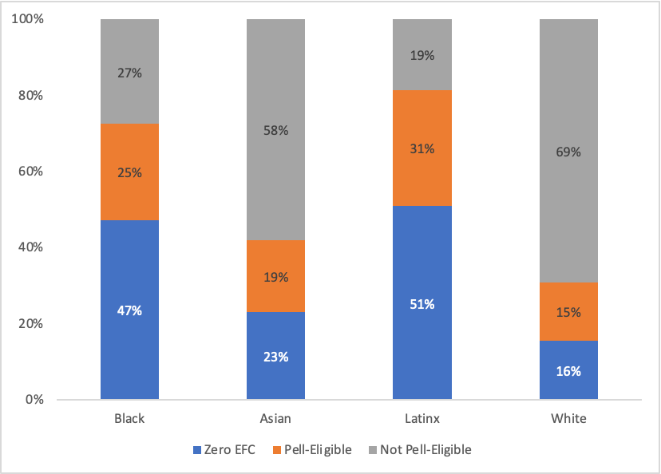
Note: This sample is limited to students who reported their race (N=8,030).

Figure A2. Methods to Pay for College by EFC
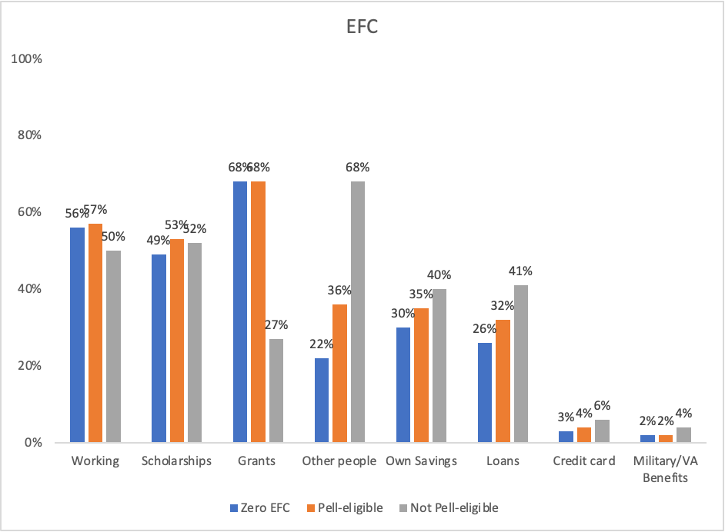
Note: Sample for this figure is limited to respondents who indicated plans to attend college in Fall 2023 and answered the question “How do you plan to pay college tuition and fees? (Check all that apply)” (N=8,174).

Figure A3. Methods to Pay for College by Segment
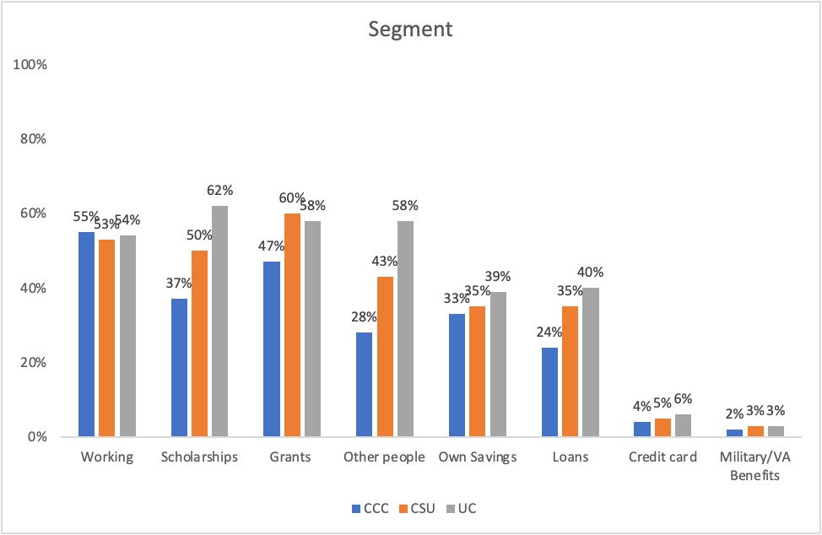
Note: Sample for this figure is limited to respondents who indicated plans to attend college in Fall 2023 and answered the question “How do you plan to pay college tuition and fees? (Check all that apply)” (N=8,174).

Figure A4. Methods to Pay for College by Race/EFC
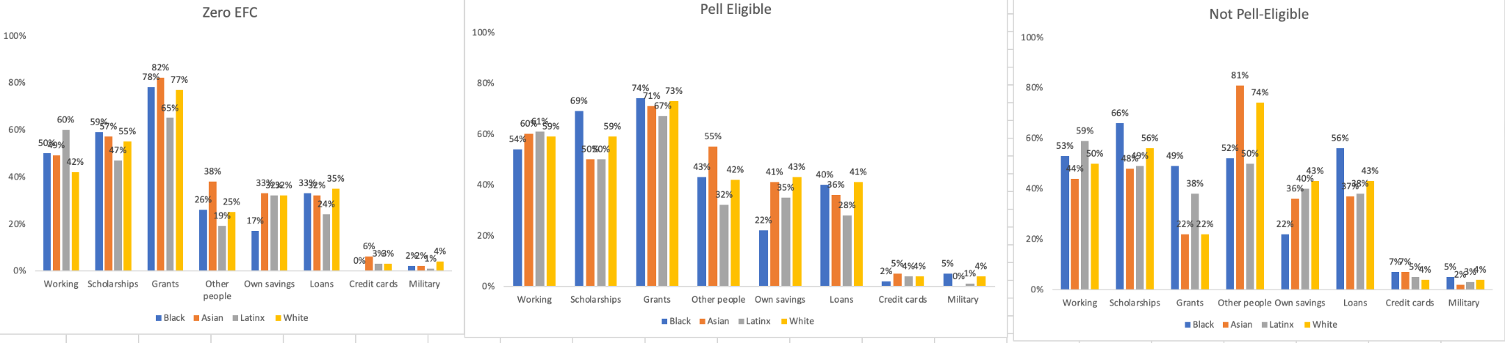
Note: Sample for this figure is limited to respondents who indicated plans to attend college in Fall 2023 and answered the question “How do you plan to pay college tuition and fees? (Check all that apply)” (N=8,174).

In July 2021, Governor Newsom signed into law Assembly Bill 469, which states that local educational agencies must ensure high school seniors submit the FAFSA/CADAA or opt-out form beginning in the 2022-23 school year.
Louisiana was the first state to require high school students to complete a FAFSA before graduation but the state education board removed this requirement in March 2024.
For the 2023-24 academic year, the maximum EFC to be eligible for a Pell Grant was $6,656.
Each year, the Department of Education selects students to verify that the information they submitted on the FAFSA is correct. The information required can range anywhere from a simple signature to a full IRS tax return to prove income. In California, a share of CADAA students is also required to be verified.
All responses to this open-ended question were analyzed to determine if students mentioned college affordability and then grouped by themes. The thematic codes are not mutually exclusive — meaning that students may have described challenges with more than one theme in their response.

